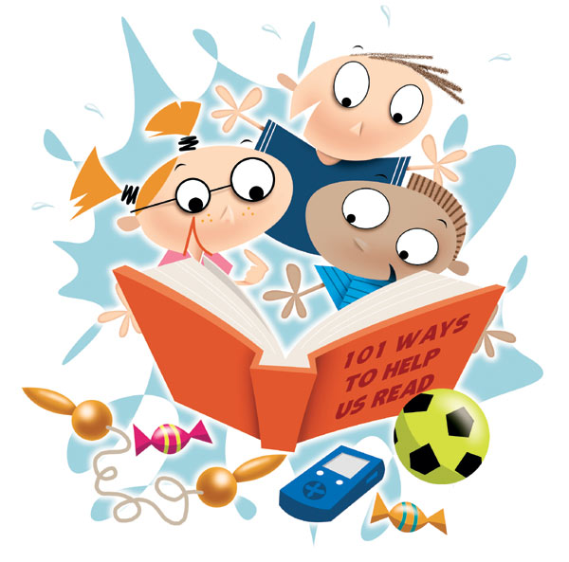

Reading is a **vital skill** that children will need in their adult life. At Wellesley, we want to encourage a **love of reading** in ALL children.

* At school we *teach* children how to read.
* At home, *practice* with help from parents and carers plays a key role too.

Research shows that parents who get involved in their child’s education make a big difference to their success at school. You can help by highlighting how important reading is and by finding ways to help your child enjoy reading at home.

Beginning the journey

Practice makes perfect

Reading for pleasure

Supporting independent readers

Encouraging boys to read

Useful stuff!

Wellesley Primary School

Parent Information Leaflet

Helping Your Child With Reading

## Why do I need to help my child with their reading?

Inside this guide:

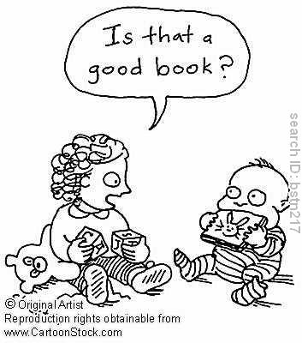

**Ideas for Reception & Year 1**

Beginning the journey

When young children are beginning to learn to read, they often learn stories off by heart so that they seem to ‘read’ a book. This is normal and means your child is becoming more confident and is beginning to understand the connection between the words on the page and the story.

### There are lots of ways that you can support your child when they are beginning to learn to read.

TIPS:

* **Build up to words**
  + Start with spotting letters they recognize, e.g. the first letter of their name.
* **Words are everywhere**
  + Read when you are out and about, e.g. words on menus, packaging, signs and tickets.
  + Label familiar things around the home with post-its.
* **It isn’t just books**
  + Try singing nursery rhymes and songs together, share comics and magazines
* **Join the library** to borrow free books.
* **Learn to love stories**
  + Make up stories together.
  + If you don’t like reading aloud, try listening to story CD’s –available from the library.
* **10 minutes a day** 
  + Reading every day, even for just 10 minutes makes a difference. Try reading on the bus or at the doctors waiting room.
* **Reading is special**
  + Give books as presents and have a special place for them.

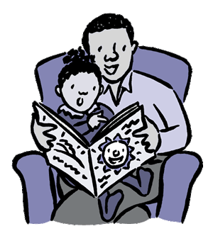

Words are built up using *‘phonemes’* which are the smallest building blocks of sound. ‘*Phonics’* is understanding how words are built up by blending these phonemes or sounds together.

e.g. Bed sounds as b – e – d, shop as sh – o – p and duck as d – u – ck.

**Teacher Talk - What is ‘Phonics’?**

TIPS:

* **Choose the right book**
  + Let your child choose books that *they* want to read as this will help their enthusiasm for reading.
  + Use pop-up or lift-the-flap books to encourage children who are reluctant to read.
* **10 minutes a day**.
  + Share a book together. Can they retell the story in their own words?
* **Make it fun**
  + Get your children to make up plays of stories they read, perhaps with their friends.
  + Read together a book you both know well and miss out words. Can your child fill in the blanks with a word of their own? This will check their understanding of the book.

### Once your child has made a start with reading, it is vital that they practice regularly to develop their skills and speed.

Children all learn at different paces and they will use a variety of methods to help them read words. These will include ‘sounding out’, looking at the shape of the letters in the word, looking at the pictures on the page and reading the words around to help them make sense of the story.

Practice makes perfect

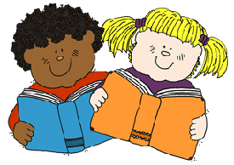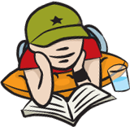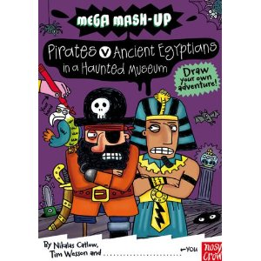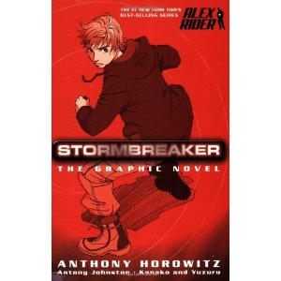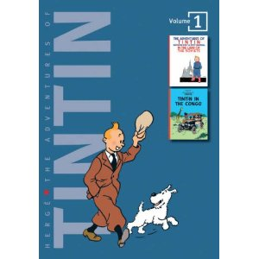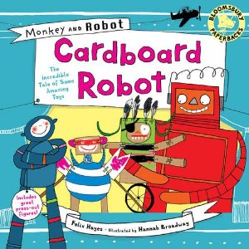

**Tips for hearing your child read**

* Use **praise** every time your child reads, even if they don’t get it right first time. This motivates them and encourages them to ‘have a go.’
* Wait before you correct your child, to give them chance to correct themselves. If they don’t then give them clues and finally praise them when they get it right.
* If your child can’t read a word, encourage them to ‘sound it out’ and to use the other words in the sentence to give them clues.
* Long words can be made easier by splitting them up into chunks (syllables), e.g. an-i-mal
* Some children need lots of practice and others want to read the same book again and again. This is a normal part of learning to read.

**Encouraging your child to read**

Once your child has learnt to read, there are lots of things you can do to help them become confident independent readers who love books, magazines, comics and newspapers.

* Continue to hear your child read. This will continue to boost confidence and show that you also value reading.
* Find books about things that your child likes, e.g. dinosaurs, football, space or TV programmes.
* Take books with you when you go on a journey or holiday.
* Enjoying a comic or magazine is still reading and great for adding enthusiasm.

### Once your child starts to get the hang of reading, it is important to keep reading regularly and to praise their achievements.

Reading for pleasure

Here are some useful prompts and discussion points for you to use when reading with your child.

*Remember to base your answers on the text.*

* **Deduce or infer from the text**
  + What is the character is feeling?
  + Why did …… do that?
  + Make a thought bubble for a character.
  + If you made a movie of this book, what type of music would you use and why?
  + Why did he feel (sad/angry/happy...)?
  + How did the character feel before/ after it happened?
* **Organisation of the text**
  + How does this paragraph link back to the opening paragraph?
  + Put events that happened in order.
  + Label the parts of the text (non-fiction book).
  + Why is this bold/underlined/ italics?
  + What would be a good caption for this photo?
* **The use of language**
  + What was happening at the beginning of the story?
  + Play a TRUE/FALSE game about the story.
  + Why does the writer use the word….?
  + What words help the reader to imagine….?
  + Choose a word to describe the character. Why?
  + Which parts of the story tell you…?
* **Identifying the viewpoint of the writer**
  + What do you think the writer thinks about this topic? Why?
  + What is the main purpose of this text?
  + How does the author make you feel?
  + Why has the author included…?

Supporting Independent Readers

**As children get older and more able, towards the top of KS1 and into KS2, we focus more on the *understanding* of what they are reading – their reading comprehension skills.**

Boy-

friendly

books..

TIPS:

* **Make reading active**
  + Get your child to ‘act out’ the story and pretend to be the characters.
* **Use male role models**
  + Ask fathers, grandfathers, uncles and older brothers to read with them.
* **It doesn’t have to be books!** 
  + Use magazines and comics, TV guides and shopping lists.
* **Give lots of praise**
  + Boys usually thrive on praise and encouragement. Let them know what they are doing well.
* **Use their hobbies and interests**
  + If there is a sport or hobby try and get books that include them. There is a wide range of non-fiction books available about everything from motorbikes to pirates!
* **Try different genres**
  + Encourage them to try different kinds of books and authors to see what suits their taste e.g. Guinness Book of Records, science fiction, adventure stories.
* **Build regular reading time into the day**
  + Don’t stop reading with boys once they can read themselves as they can switch off when they know the basics.

With boys being less willing to spend time reading outside the classroom, what can parents do to encourage them to read and enjoy books?

### Traditionally, more boys than girls struggle with reading at school and boys are often less likely to enjoy reading.

Encouraging boys to read

**“I have a passion for teaching kids to become readers, to become comfortable with a book… learning to be a reader gives a terrific advantage.”**

― [*Roald Dahl*](http://www.goodreads.com/author/show/4273.Roald_Dahl)

The Booktrust - [www.booktrust.org.uk](http://www.booktrust.org.uk) has monthly recommendations for good children’s books and a wide range of information about reading in general.

The National Literacy Trust – [www.literacytrust.org.uk](http://www.literacytrust.org.uk) has ideas to support children’s reading in different age bands. They also have book lists recommended for boys.

[www.thebookpeople.co.uk](http://www.thebookpeople.co.uk) often offer books at very reasonable prices, especially sets of books.

We hope you have found this guide useful and informative. If you have any further concerns about your child’s reading, then please make an appointment to see your child’s class teacher.

Reading Guidance

Wellesley Primary School

Useful stuff!

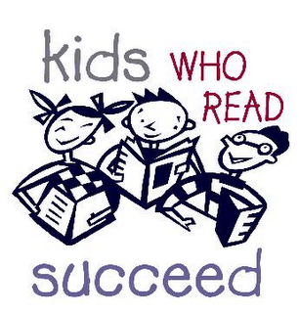

Published October 2012